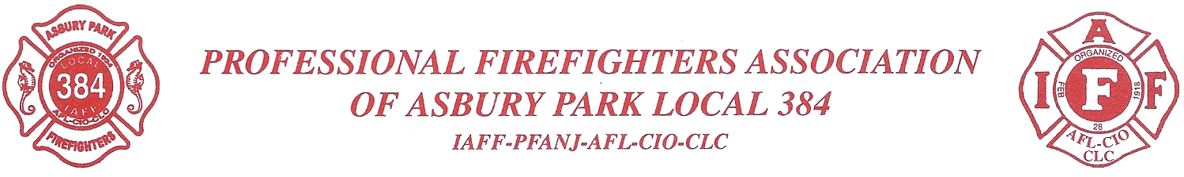

On June 19, 2023 The Professional Firefighters Association of Asbury Park will be holding its 24th Annual Golf Tournament at Cruz Farms Golf Club in Farmingdale, NJ to benefit the many charities that our organization supports. Most of the players who are participating represent professional firefighters throughout New Jersey. With over 175 players taking part, it is one of the largest single-day golf tournaments held in the state. Our non-profit charities organization contributes to many worthwhile causes during the year. Some of the recipients of this fund are Asbury Park Pop Warner, Monmouth County Boys Club, Biddy Basketball, Asbury Park Soccer and Little League. Others include the Monmouth County Food Bank, Muscular Dystrophy Association, American Breast Cancer Foundation, Adopt-A-Family at Christmas, Widows and Children’s Fund of New York Fire Department, National Association for Colitis and Crohn’s Disease, Sloan Kettering, and St. Barnabas Burn Center.

Our organization, along with the many charities that we assist, would greatly appreciate your support this year with a sponsorship or gift. In return, have your company name or logo displayed at our outing in the following ways:
$200 or more Tee Sponsor (1’x2’’ sign)
$500 or more Hole sponsor (3’x 5’ sign)
$1,000 or more Lunch & Dinner sponsor (3’x10’ banner)

Additionally, any donation of prizes and gifts for winning participants and raffle is needed and greatly appreciated! For further information, please contact me via cell at (732)-684-2020. Checks made payable to APFF Local 384, 800 Main St, Asbury Park, NJ 07712.

On behalf of the Asbury Park Firefighters, I thank you for your time and consideration.

Sincerely,

Robert Fahnholz
Delegate
Asbury Park Firefighters IAFF 384

THE ASBURY PARK FIREFIGHTERS CHARITIES ORGANIZATION IS A MEMBER OF THE NEW JERSEY STATE REGISTERED CHARITIES AND REGISTERED BY THE NEW JERSEY STATE DIVISION OF PUBLIC AFFAIRS AND LEGALIZED GAMES OF CHANCE CONTROL COMMISSION #12-4-32331.

